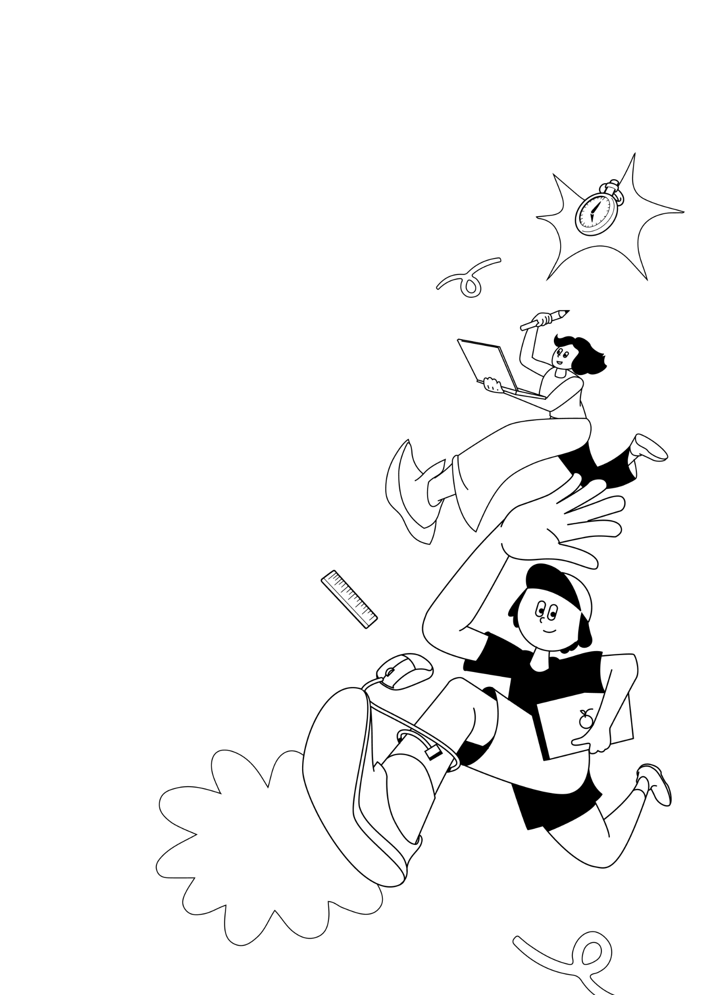
LKSN 2024

TEKNOLOGI
DESAIN GRAFIS

Module 3 (EN)
New Media

LKS Nasional
AGUSTUS 2024

INSTRUCTIONS FOR COMPETITOR

- Create a folder named Competitor Number_Your Name
  - The folder must contain all final files in the format specified in the technical specification.
- You must use all the text provided in the appendix for each tasks as specified, adding or subtracting text from the appendix is ​​not allowed.
- You may use the image/photo assets that have been provided.
- You may use create raster element or additional vector provided.
- You are not permitted to use images/photos from internet or from sources other than provided.

Example of arranging folders on a Competitor’s computer:
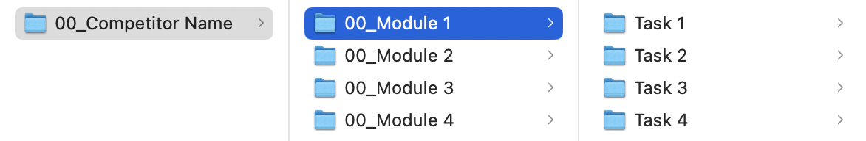

MODULE FOLDER
Module 3

PROJECT DESCRIPTION AND TASKS
This module consists of 3 (THREE) tasks that you have to do, you are not allowed to do outside the time limit that has been given.

TASK 1: SOCIAL MEDIA CONTENT

OBJECTIVE
Apply the logo and visual identity to social media content using the key visual explanation that have been provided at Module Y.

REQUIREMENT
You must include:
- Minimum 2 images.
- Studio on Fire Logo.
- M Bloc Logo.
- QR Code.

TECHNICAL SPECIFICATION
Dimension : 1 x Vertical Post (1080 x 1920 px)
1 x Square Post (1080 x 1080 px)
Image Resolution : 72 ppi
Color Mode : RGB
Elemen Desain : Minimum 2 Images, 2 Logos, QR Code
Teks : Module 3 Appendix 1.pdf

Working File Format : AI
Final File Format : JPG
Image Format : PNG, JPG, PSD, AI, EPS, SVG

Folder Name : Competitor Number_Module 3
Sub Folder Name : Task 1
File Name : Competitor Number_Module 3_Vertical
Competitor Number_Module 3_Square

YOU MUST DELIVER
Folder & file names as specified in "INSTRUCTIONS FOR COMPETITOR".
Only links & files from this folder will be marked.

1 x AI (Working File)
2 x JPG (Final File)

TASK 2: LOW-FIDELITY PROTOTYPE

OBJECTIVE
Create Low-fidelity Prototype using the key visual that have been provided at Module Y.

REQUIREMENT
- Use template provided (Template Low-Fidelity).

TECHNICAL SPECIFICATION
Dimension : Template provided (1650 x 900 px)
Image Resolution : 72 ppi
Color Mode : RGB
Feature : Radio Button, Clickable and Fillable, Hyperlinks,
Page Transition Effect, Pop Up Panel, Menu
Teks : Module 3 Appendix 1.pdf

Working File Format : AI or PSD
Final File Format : JPG
Image Format : PNG, JPG, PSD, AI, EPS, SVG

Folder Name : Competitor Number_Module 3
Sub Folder Name : Task 2
File Name : Competitor Number_Module 3_Lofi

YOU MUST DELIVER
Folder & file names as specified in "INSTRUCTIONS FOR COMPETITOR".
Only links & files from this folder will be marked.

1 x JPG (Final File)

TASK 3: HI-FIDELITY PROTOTYPE

OBJECTIVE
Create Hi-fidelity Prototype based of Low-fidelity Prototype that have you crated from Task 2. Then, create the design presentation for the preview of your prototype that have been made as simple and efficient as possible.

REQUIREMENT
- Studio on Fire Logo.
- M Bloc Logo.

TECHNICAL SPECIFICATION
Dimension : Frame iPhone 15 (390 x 844 px) - Figma
Design Presentation (1920 x 1080 px)
Image Resolution : 72 ppi
Color Mode : RGB
Feature : Radio Button, Clickable and Fillable, Hyperlinks,
Page Transition Effect, Pop Up Panel, Menu
Teks : Module 3 Appendix 1.pdf

Presentation Format : AI, PSD, or Figma

Working & : Figma
Prototype File Format
Presentation File Format : JPG
Image Format : PNG, JPG, PSD, AI, EPS, SVG

Folder Name : Competitor Number_Module 3
Sub Folder Name : Task 3
File Name : Competitor Number_Module 3_Hifi

YOU MUST DELIVER
Folder & file names as specified in "INSTRUCTIONS FOR COMPETITOR".
Only links & files from this folder will be marked.

1 x Figma Prototype Link (Final File)
1 x JPG (Final Preview)

